C h a p t e r
7
Atomic Structure and Bonding

1. [6 marks] (2004:02)
For each species listed in the table below, draw the structural formula, representing all
valence shell electron pairs either as : or as - .

Species | Structural formula  (showing all valence shell electrons)
Nitrogen trifluoride, NF3
Boron trifluoride, BF3
Sulfate ion, SO 2–
4

2. [2 marks] (2004:03)
Write the electron configuration (using s, p, d notation) for the following species:

(a) O2-

(b) Ca

Which one of the following diagrams best represents a hydrogen bond? Circle A, B, C or D.

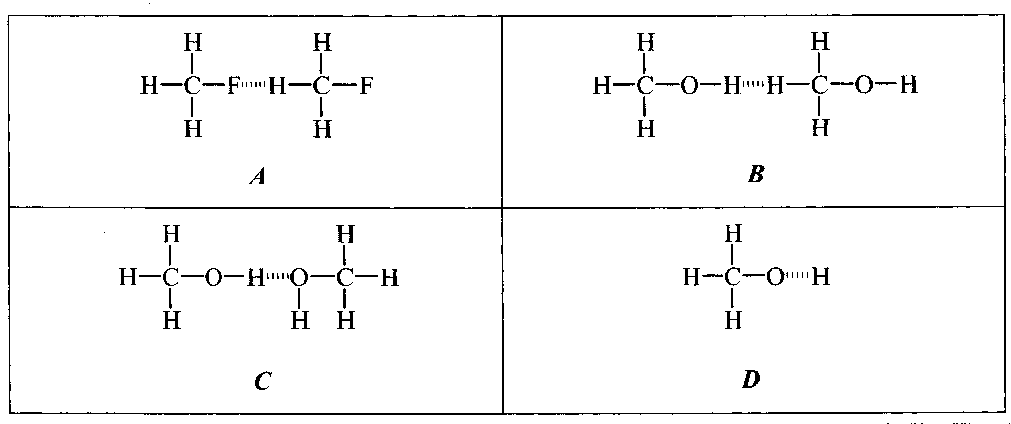

Explain your choice.

For each species listed in the table below, draw the structural formula, representing all valence shell electron pairs either as : or as - .

Species | Electron-dot diagram | Shape (name or sketch)
Silane
(Silicon tetrahydride)
SiH4
Phosphorus trichloride PCC3
Carbonate ion
CO₃ 2–

For each of the following substances, provide a common use and the property that is responsible for that use.

Substance | Use | Property
Aluminium
Diamond
Zinc
Stainless steel

6. [3 marks] (2005:05)
Explain in terms of intermolecular forces why methylated spirits (mainly ethanol) is more effective than water for removing grease from clothing.

7. [2 marks] (2005:08)

Buckyballs (Buckminsterfullerene molecules) are a molecular form of carbon with the formula C60. Will buckyballs conduct electricity? Justify your answer.

8. (6 marks)
For each species listed in the table below, draw the structural formula, representing all valence shell electron pairs either as : or as - .

Species | Electron dot diagram
Hydrogen sulfide, H2S
Sulfuric acid, H2SO4
Magnesium nitrate, Mg(NO3)2

Consider the following chemical substances.

CO2 SO3 NH3 H2O N2 S8 Cl2 CCl4

List all the molecules that contain polar bonds.
List all the polar molecules.
List all the linear molecules.
(Note: Substances can be listed in more than one category)

10. [3 marks] (2006:04)
On Earth, water evaporates, forms clouds and falls back to the ground in a process known as the ‘water cycle’.

On Saturn’s moon Titan, where the average temperature is 94 K (–178°C), methane behaves in the same way as water does on Earth, evaporating and raining onto the surface as a liquid.

Using your knowledge of their structure and bonding, explain why water and methane undergo these processes at such different temperatures.

Draw the electron dot diagrams of the following -valence shell electron pairs either as : or as - .

Species | Electron dot diagram
Ethanol
Potassium hydroxide

12. [4 marks] (2007:03)
On Earth, nitrogen exists as a gas. On Triton, the largest moon orbiting the planet Neptune, nitrogen can exist as a solid. The surface temperature of Triton is around –235°C.

Name the force of attraction that exists between nitrogen molecules.

Explain how these forces arise and why the temperature needs to be so low for nitrogen to be a solid.

13. [6 marks] (2008:P2:02)

For each species listed in the table below, draw the structural formula, representing all valence shell electron pairs either as : or as - .

(for example, water or or and so on)
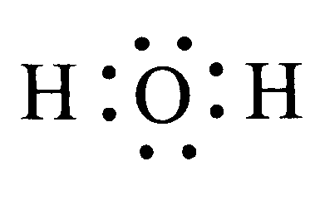

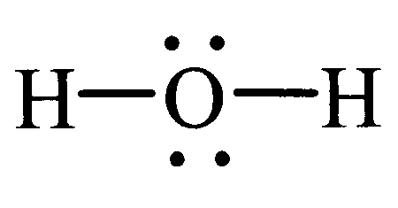

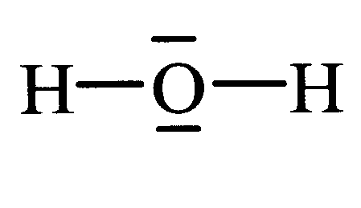

Species | Electron dot diagram
Nitrogen gas
Sodium nitrate
Hydrazine, N2H4

14
valence shell electron pairs either as : or as - and state or draw the shape of the molecule or ion.

(for example, water or or bent)
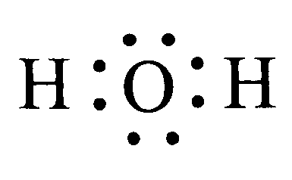

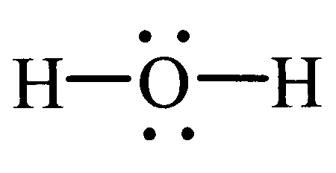

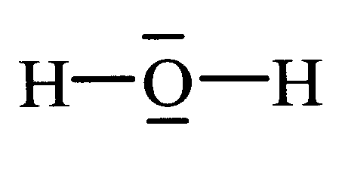

Species | Structural formula (showing all valence shell electrons) | Shape (draw or state name)
CO2
CH2O
HCO₃ –

15. [4 marks] (2009:07)

(a) Explain why the first ionisation energy of elements increases going from left to right across row 3 of the periodic table, i.e. from Na to Ar. [2]

(b) Below are the successive ionisation energies (IE) for the magnesium atom. [2]

1st IE 744 kJ mol–1
2nd IE 1457 kJ mol–1
3rd IE 7739 kJ mol–1
4th IE 10547 kJ mol–1

(i) Explain why the second ionisation energy is greater than the first ionisation energy.

(ii) Explain the significant increase between the second and third ionisation energies.

SOLUTIONS

1.(2004:02)
*

SO4
Species | Structural formula (showing all valence shell electrons)
Nitrogen trifluoride NF3 | N  F  F  F
Boron trifluoride BF3 | F OR F  B B  F* F F* F
Sulfate ion
2–
Sulfate ion  2– |  |  | O  O S O O | 2–

2.(2004:03) a) O2– 1s2 2s2 2p6
b) Ca 1s2 2s2 2p6 3s2 3p6 4s2
3.(2004:10) Hydrogen bond exists between two different molecules. An O or N or F bonded to a hydrogen atom, which has an appreciable positive charge due to unequal sharing of the electrons, has hydrogen bonding. These criteria exclude A, B and C, leaving only D to represent a hydrogen bond.
4.(2005:02)

Species | Electron-dot  diagram | Shape (name or  sketch)
SiH4 | H  •  x  H • x Si x • H  x  •  H | H  Si  H H  H  Tetrahedral
PCC3 | x x • • x x  x CC• P •CCx  x x •x x x x x x x x x  x CC x x x | ••  P  CC CC  CC  Pyramidal
CO 2–  3 | • •  • O •  • •  x x  •• x Cx x  O •••  x  •••• •••  O | O 2– C  O O  Triangular planar

5.(2005:03)

Substance | Use | Property
Aluminium | • Cooking pots and pans  • Electrical cables  • Frames for windows  • Aircraft bodies | • High thermal conductivity  • Good electrical conductivity  • Prevents extensive corrosion  • Low density
Diamond | • Drill bits for rock drilling, cutting and shaping other diamonds  • Ornamental jewellery | • Very hard  • High internal reflectivity
Zinc | • Galvanising iron roofs  • Anodes in dry cells  • Reducing agents in many reactions | • Prevents iron roof from corrosion by elements  • Ease of oxidation  • Low reduction potential
Stainless  steel | • Knives, forks, spoons, surgical instruments, wood-working tools etc. | • Hardness  • Rust resistance

molecules are much weaker compared to the hydrogen bond forces which hold water molecules together. On the other hand, the intermolecular forces between the methylated spirit molecules and the grease molecules are stronger than the intermolecular forces between the grease molecules, or between the methylated spirit molecules. Dispersion forces between the CH3CH2OH molecules and the grease molecules provide enough energy to break the attraction forces between the grease molecules. This is why CH3CH2OH molecules remove the grease molecules from the clothing.
7.(2005:08) No. In a molecule of C60, each carbon atom is attached to three other carbon atoms in much the same way as in graphite. This leaves one delocalised electron for each carbon atom in the molecule. However, Buckminsterfullerene is a covalent molecular substance and does not conduct electricity. The molecules are discrete with the delocalised electrons within each.
8.(2006:02) Structural formulae, representing all valence shell electrons:
Hydrogen sulfide, H2S Sulfuric acid, H2SO4 Magnesium nitrate, Mg(NO3)2
Sulfuric Acid
Magnesium Nitrate

H S H
•
• S •
x • • x
H H
O 2– –
2+ O

+
2 H +
O S O

O
x x ••
x O • S •x O x•H
x x x • •
x
O
x
•
H
Mg + 2

O N O

9.(2006:03)

S lf i A id

All molecules that contain polar bonds | CO2, SO3, NH3, H2O, CCC4
All the polar molecules | NH3, H2O
All the linear molecules | CO2, N2, CC2
10.(2006:04) Water (H2O) has a boiling point of 100°C and freezing point of 0°C on earth at sea level and one atmospheric pressure. The relatively high boiling point and freezing point of water can be attributed to the fact that its molecules are bound by strong hydrogen bonding though water molecules are also weakly bound by dispersion forces. This hydrogen bonding is a special form of dipole-dipole interaction and the shared electrons are strongly attracted towards the more electronegative atoms. Since the hydrogen atom has a positive charge, it experiences a strong attractive force with lone pairs of electrons on the oxygen atoms of neighbouring molecules. Hydrogen bonding is also particularly strong in ice. Due to the strength of this strong intermolecular force, a higher temperature is necessary for breaking the H2O molecules from ice and free H2O molecules from water.

Hydrogen bonding in water
H O

O H H

H

Methane (CH4) is a gas at similar temperatures at which water is a solid or liquid. The only intermolecular force that binds the methane molecules is dispersion force of a temporary dipolar nature. These temporary dipoles occur at any moment when the electron clouds deviate from symmetry and influence the temporary polarity of other nearby molecules. These dispersion forces are of very small magnitude due to the small size and the number of atoms in methane. However, methane can be condensed to a liquid at low enough

temperatures such as those which occur on Titan. This produces methane showers and evaporation under these conditions similar to our ’water cycle’ on earth.

Intermolecular forces in methane
FORCES OF ATTRACTION H BETWEEN TEMPORARY H
DIPOLES IN METHANE MOLECULES C
H H C
H H H H

11.(2007:02) Structural formula for ethanol Structural formula for KOH

H H + –

+ –
K + O H

H C C O H
K + O H

H H

12.(2007:03) The force of attraction that exists between nitrogen molecules is due to dispersion or

O H
London forces.

Nitrogen must be cooled enough to condense as a liquid and then as a solid on further cooling, as the molecules do not possess permanent dipoles. Temporary dipoles occur all the time, as the electrons around the nuclei are not always evenly distributed. These forces are produced across the entire range of molecules at any instant. Molecules and atoms with temporary dipoles induce temporary dipoles in the neighbouring atoms or molecules. These temporary dipoles are short lived but continuously occur throughout the substance, keeping the molecules close in a liquid or solid state. Dispersion forces are also affected by the shape, size and symmetry of molecules along with the number of electrons present.
13.(2008:P2:02)

Species | Electron Dot Diagram
Nitrogen gas | N N N N
Sodium nitrate | - -  + +  Na N Na N  O
Hydrazine  N2H4 | H N N H H N N H H H H H

14.(2009:2)

Species | Structural formula (showing all valence shell electrons) | Shape (draw or state name)
CO2 | O C O | Linear
CH2O | H  C O H | Trigonal (or triangular)  planar
HCO –  3 | O C  O O  H | Trigonal (or triangular)  planar

15.(2009:7)
a) Each successive electron comes from the same energy level. However each is at a diminishing distance from the nucleus. This is due to the decreasing size of the atom which is caused by the increasing force of attraction of the nuclear charge. Thus each successive electron experiences a slightly greater force of attraction by the increasing nuclear charge, which increases the energy required to remove it.
b) i) The first electron is removed from a neutral atom in which the numbers of electrons and protons are equal. The second electron is removed from a positively charged ion that contains more protons than electrons and thus the electron experiences a stronger attraction from the nucleus.
ii) The second electron is removed from the same energy level as the first. However, the third electron is removed from an inner energy level, which is closer to the nucleus and which experiences a stronger force of attraction by the nucleus.

